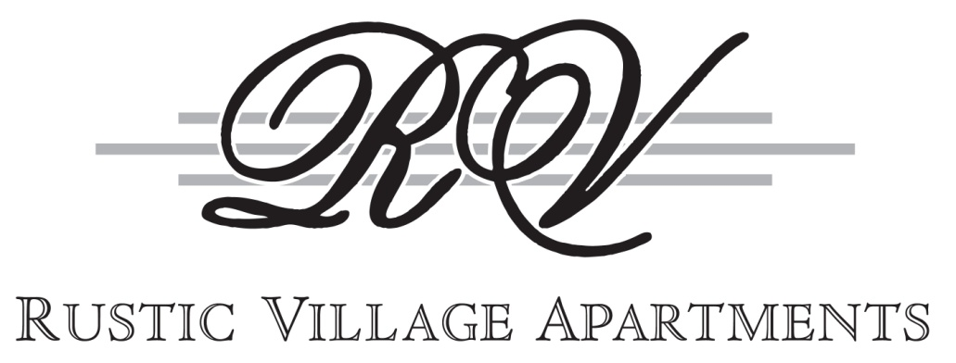

APARTMENT Pricing

ONE BEDROOM APARTMENTS APPROX. SQUARE FOOTAGE*

$870 PLAN A Standard Garden Level Apartment 750
$895 PLAN D Oversized Bedroom w/ Walk-In Closet 800

TWO BEDROOM APARTMENTS

$940 PLAN B Lower Level 900
$955 PLAN B Upper Level 900

$975 PLAN C Larger Kitchen 950
*upper level only

$1045 PLAN E Lower Level- 2 Full Baths 1040
$1065 PLAN E Upper Level- 2 Full Baths 1040

$1085 PLAN F Larger Kitchen- 2 Full Baths 1110

*upper level only

All of the above listed apartment prices are based on a 1-year lease term.

Furnished Corporate Suites are available on a short or long-term basis.
Ask your Rental Consultant for further details.

Pets are permitted in designated “Pet Friendly” buildings only. Our pet policy and fees are as follows:
- One (1) small dog (25 lbs. full grown) - $30 per month
- One (1) large dog* (over 25 lbs) - $50 per month *breed restrictions apply
- One (1) cat - $30 or two (2) cats - $40 per month
- A $150 refundable pet deposit is required

There is a $35 non-refundable application fee required for each rental application. A Renters Insurance Policy is required for your entire lease term and must have a minimum personal liability of $300,000. The security deposit is equal to one month’s rent, however, management reserves the right to request additional security deposits based on employment, past rental, or credit history of the applicant(s). A non-refundable $200 redecorating fee is automatically deducted from the security deposit.
See our “Student Policy” for information regarding students.

ALL PLANS INCLUDE HEAT AND HOT WATER

999 East Henrietta Road • Rochester, NY 14623 • Phone (585) 424-4380
Fax (585) 272-7073 • www.rusticvillageapartments.com
Rev. 3/21/17

Rustic Village has been an integral part of Rochester living for over thirty years and you are invited to be a part of it. Situated on 100 acres, our community is in the Town of Brighton, conveniently located near the 390 and 590 expressways. In addition, our property is on the Rochester Transit System bus route.

We offer a variety of floor plans and are certain that one will suit your needs. We also offer Furnished Corporate suites, for short or long-term lease options.

INTERIOR FEATURES COMMUNITY FEATURES

Neutral décor throughout 24-Hour resident assistance/emergency maintenance
Full size GE appliances Supervised pool and lounging areas w/ Wi-Fi connection
Built-in microwave, dishwasher, & air conditioner Children’s wading pool & playground
Hardwood kitchen cabinets Tennis and sand volleyball courts
Separate dining area with ceiling fan Basketball and handball courts
Plush wall-to-wall carpeting Plenty of walkways for leisurely strolls
Custom window treatments throughout Electric car charging station
Secured intercom entry Reading library with Wi-Fi
Laundry facilities in each building Fitness center
Storage area included for each apartment Entertaining center with full kitchen
Extra storage available for nominal fee Fenced-in dog park
Planned seasonal gatherings & social activities
Carwash & vacuum area
CONCIERGE SERVICES Direct TV & dish capability in established buildings

Package acceptance FOR YOUR CONVENIENCE
Fax & copy center
Vehicle jump-starts Close to work, cultural events, shopping and every kind
DVD Library of dining, entertainment and year round sporting events
ATM
Just minutes from:
Rochester International Airport
Items to Borrow: Major corporate centers and restaurants
Tool boxes Strong Memorial and Highland Hospitals Sporting equipment The Sports Centre at MCC
Folding tables & chairs Marketplace Mall and Southtown Plaza
Hand carts Rochester Institute of Technology
University of Rochester
 Rochester Centre City
JCC

Please come in for a tour! You can be assured that our knowledgeable and professional staff will go out of their way to provide you with the best service available during your Rustic Village experience.

